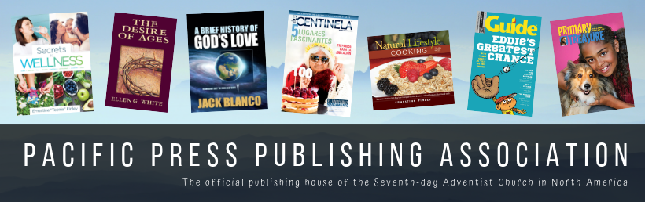
Press Release
CONTACT:
Alicia Adams | Director of Marketing | Alicia.Adams@PacificPress.com
Office: 208-465-2550 | Cell: 805-573-0848

Guide Magazine Publishes a Special Sharing Issue on the State of the Dead

Nampa, Idaho (September 17, 2020) — Guide magazine has produced Deaths’ Doom, a 16-page outreach magazine for readers ages 10–14 that uses Guide’s famous storytelling technique along with related sidebars to help kids understand the biblical view of death and the hope we have in a future resurrection. This interactive issue includes an issue-wide puzzle and access to a website (which will go live on October 31, 2020) with additional resources that reaches young and old alike.
  - A Timely Message for an Unchurched Audience
According to Barna Research, 30% of the world’s population is under the age of 15, 70% of children are born into non-Christian homes. Forty million children in North America haven’t heard the Gospel and 85% of all Christians accept Christ before the age of 14.
“The challenges and opportunities represented by these numbers give us a clear mandate to invest in children's evangelism,” says Carl McRoy, Literature Ministries Director of the North American Division. “Helping children deal with painful and confusing situations through compelling, Bible-based storytelling has been more effective in building up the kingdom than apologetics directed at adults.”
  - A Spirit-led Endeavor
In upcoming special issues, Guide will focus on Adventist distinctive beliefs.
Guide editor Lori Futcher says, “We planned Death’s Doom before the pandemic and feel this message is desperately needed. Children aren’t confronted with the reality of death as often as adults, but the pandemic and recent catastrophes have brought death closer to home. Because it will be ready in time for Halloween, it provides a perfect witnessing opportunity.”
  - A Spiritual Battle
“The devil made sure we knew that he doesn’t want us to share Death’s Doom,” says Guide managing editor Laura Sámano. “His attempts to discourage us didn’t surprise us, because Death’s Doom tells readers that Jesus killed death at the cross.”
Despite the spiritual battle that was waged in order to produce this magazine, Pacific Press had received preorders for 60,000 of the 100,000 printed.
  - An Effective Outreach Tool
Pastor Chris Evenson who serves at the Nampa Seventh-day Adventist Church, a congregation that has already bought magazines for the church says, “The stories in this edition are right on point! Topics covered are those in the forefront of the minds of people today. They are handled in a biblically-based fashion and bring hope for humanity! This is a great magazine to share with friends and neighbors.”
  - Church Involvement
Churches, schools, Pathfinder clubs and families may order Death’s Doom for zip code mailings, to include it in care packages, to distribute at Halloween, or to share one-on-one with kids and adults. Preview the full issue of Death’s Doom at AdventistBookCenter.com/DeathsDoom.
Death’s Doom is now available in all Adventist Book Centers across the North America Division. It can also be ordered online at AdventistBookCenter.com/DeathsDoom or by calling 800-765-6955.
  - Prices:
Buy 10 for $0.25 each and save 17%
Buy 100 for $0.20 each and save 33%
Buy 1000 for $0.15 each and save 50%

###

