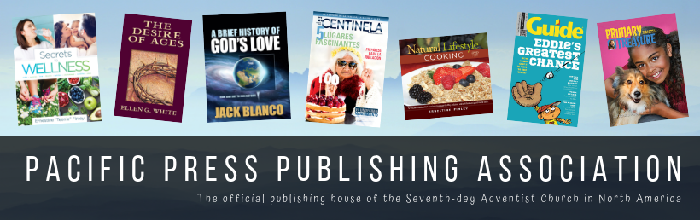
Press Release
CONTACT:
Alicia Adams | Director of Marketing | Alicia.Adams@PacificPress.com
Office: 208-465-2550 | Cell: 805-573-0848

Online Camp Meeting Sale July 11–16 Features Big Discounts

Nampa, Idaho — Snapping up new and best-selling books at deep discounts during camp meeting “auditorium sales” is a much-anticipated Adventist tradition. Pacific Press Publishing Association and AdventistBookCenter.com will host an online summer camp meeting sale July 11 through 16.
The online sale will feature the deep discounts camp meeting attendees are accustomed to finding during the in-person sales. Shoppers will be able to visit AdventistBookCenter.com during the sale dates to see the list of featured products and order their favorites at as much as 33 percent off retail. Shipping on most orders over $50 is free (some products, such as magazines and tracts, are excluded; find the “This product qualifies towards the free shipping offer” designation under the author’s name on the product page).
In addition to the list of products featured all week, each day will have one or more bonus deals in categories including kids’ books, stories, Bibles, cookbooks, Spirit of Prophecy, and more. Local Adventist Book Center retail stores may also offer specials on other products, including vegetarian foods. Learn about those deals by subscribing to your local store’s email newsletter, following their social media channels, or calling the store directly at 800-765-6955.
For more information, visit AdventistBookCenter.com/CampMeetingSale, subscribe to the AdventistBookCenter.com email newsletter, and follow on social channels.
###

